**Using Dicom Server on Windows-**

1) download dicomserver1419.zip from the given link-

2) Create Directory Dicomserver.

md c:\dicomserver c

d \dicomserver

unzip DICOMSERVER1419.ZIP

 conquestdicomserver

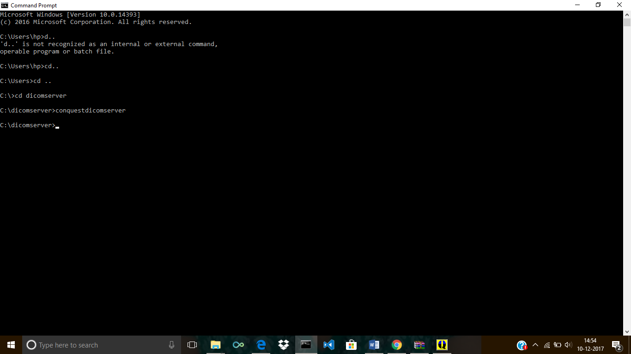

3)

After running conquestdicomserver following appears.

Select default Install here-

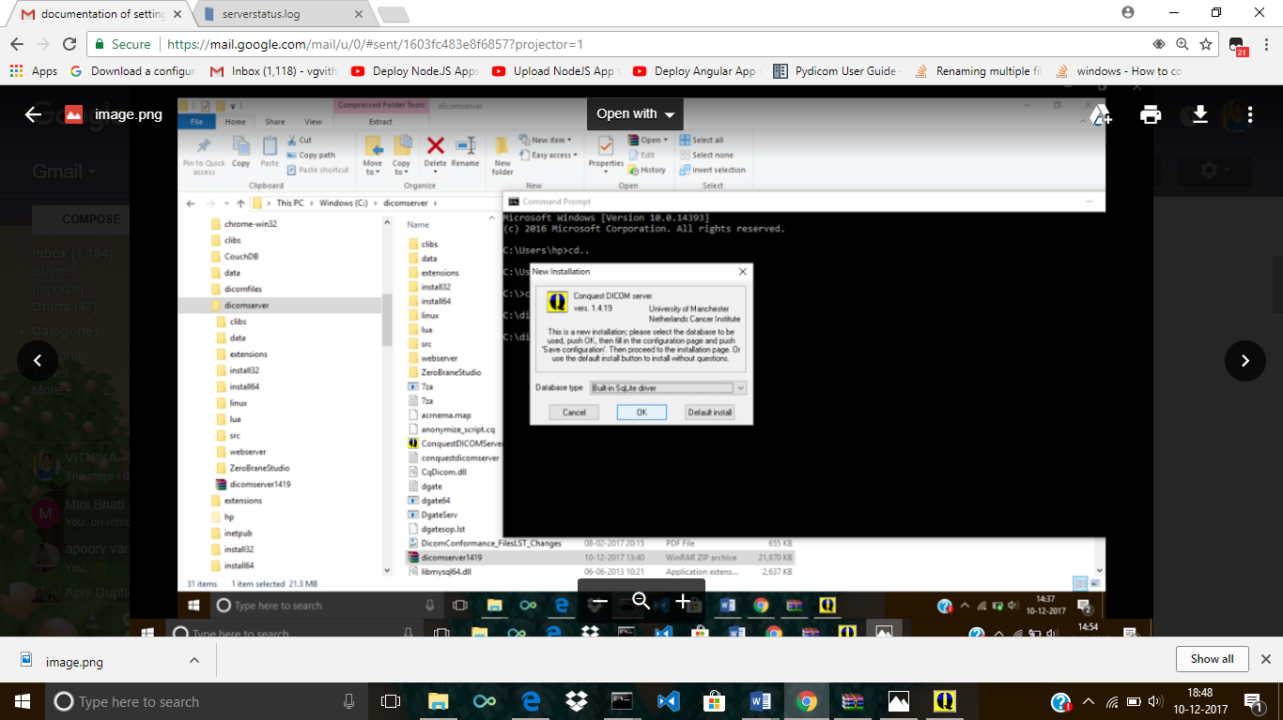

4)Select Save configuration after Enter the name of server and other details(Path of Stored Images)

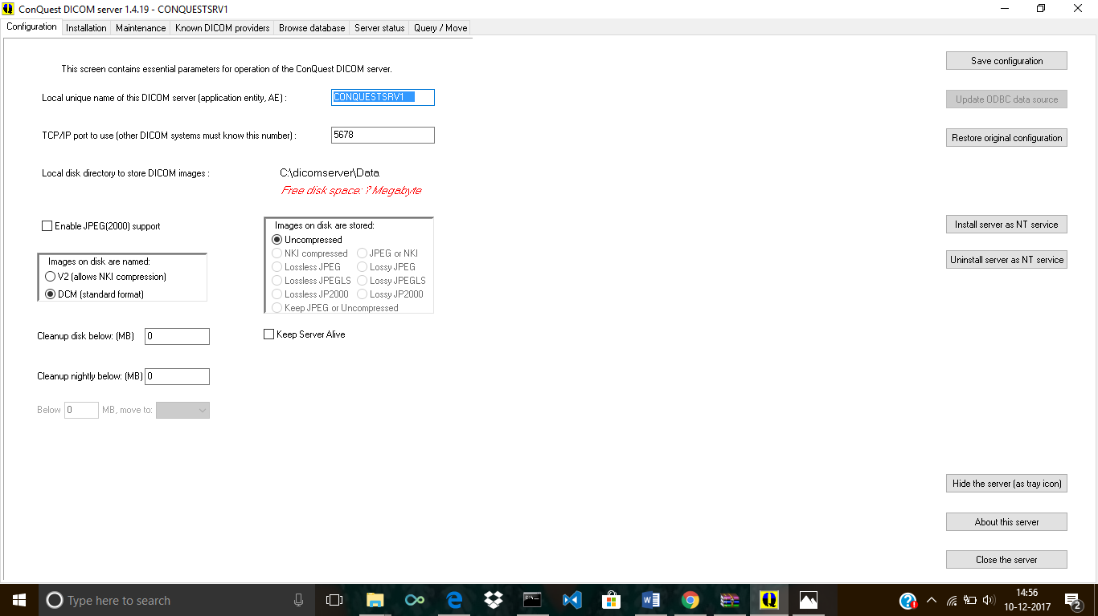

5)Now click on second Tab Installation and select Verify TCP/IP

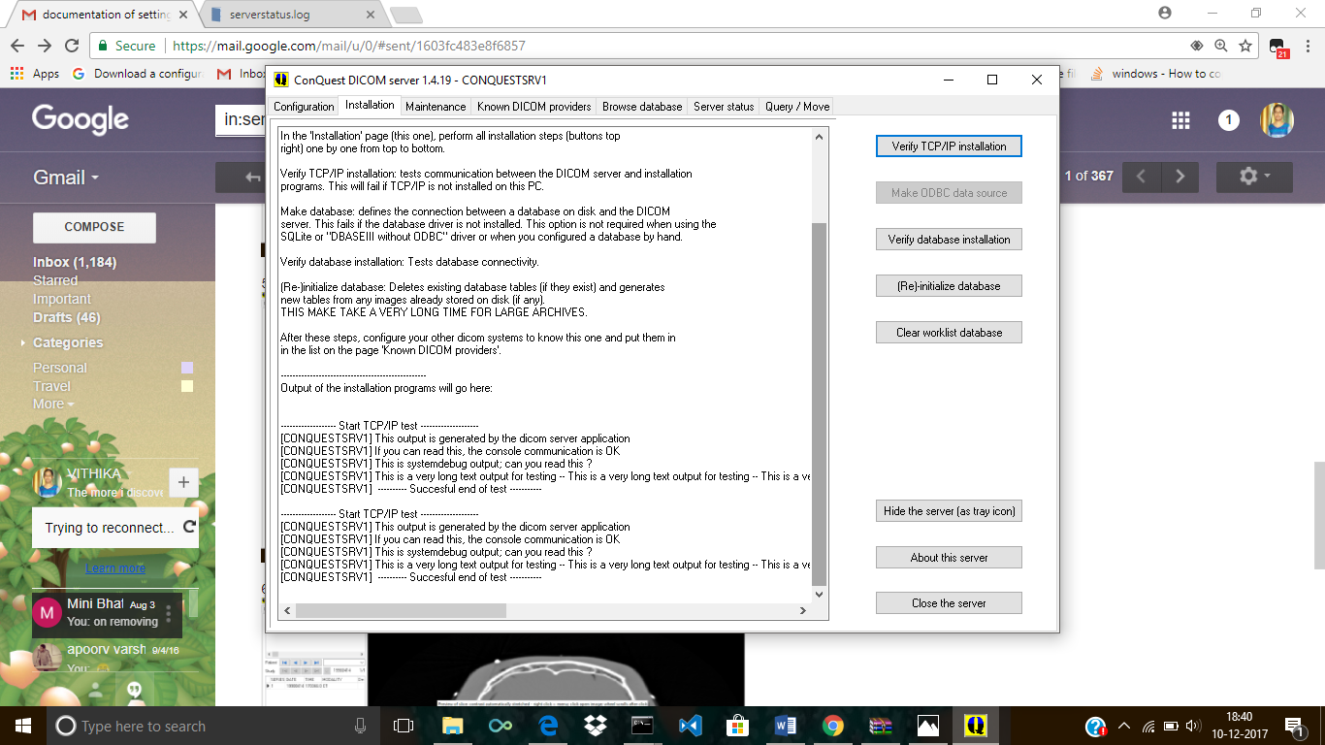

6)Maintainence Tab –

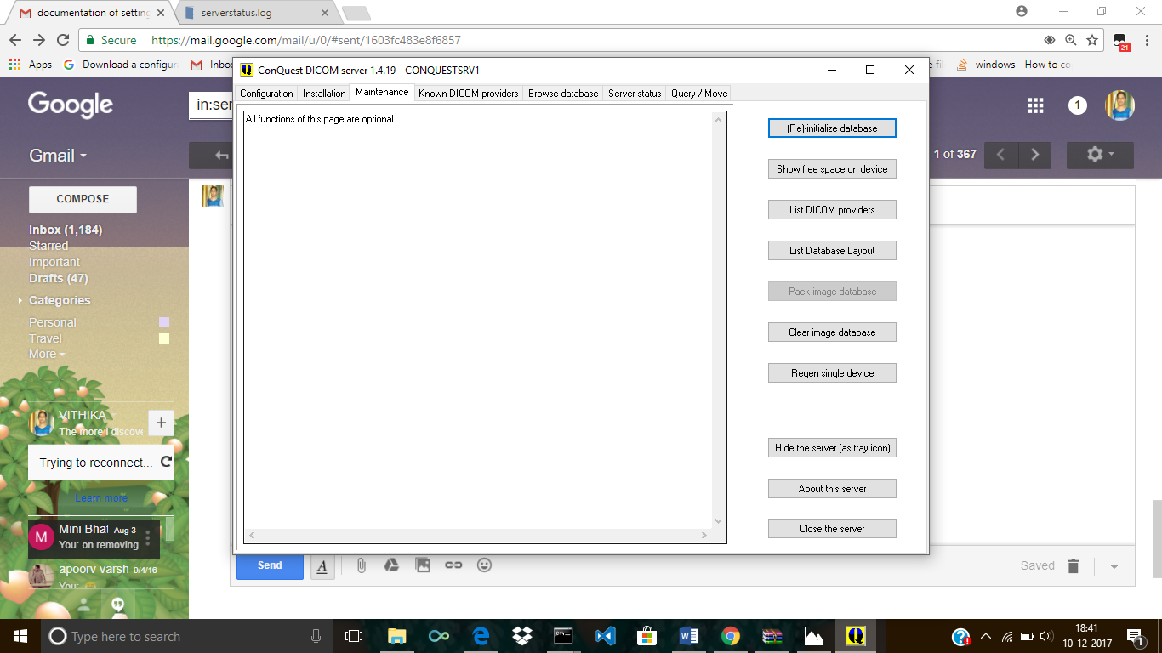

7)Known Dicom Providers-

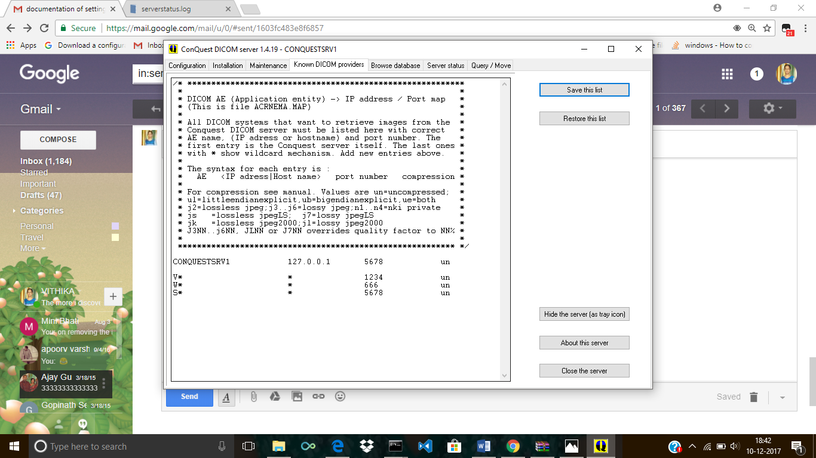

Click on Save this List-

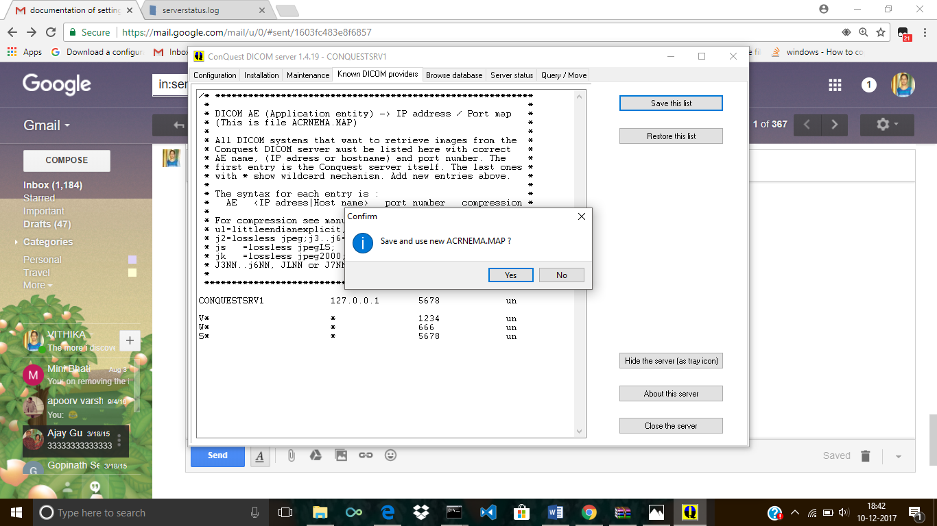

8)Click on browse database and use the arrow keys to see images-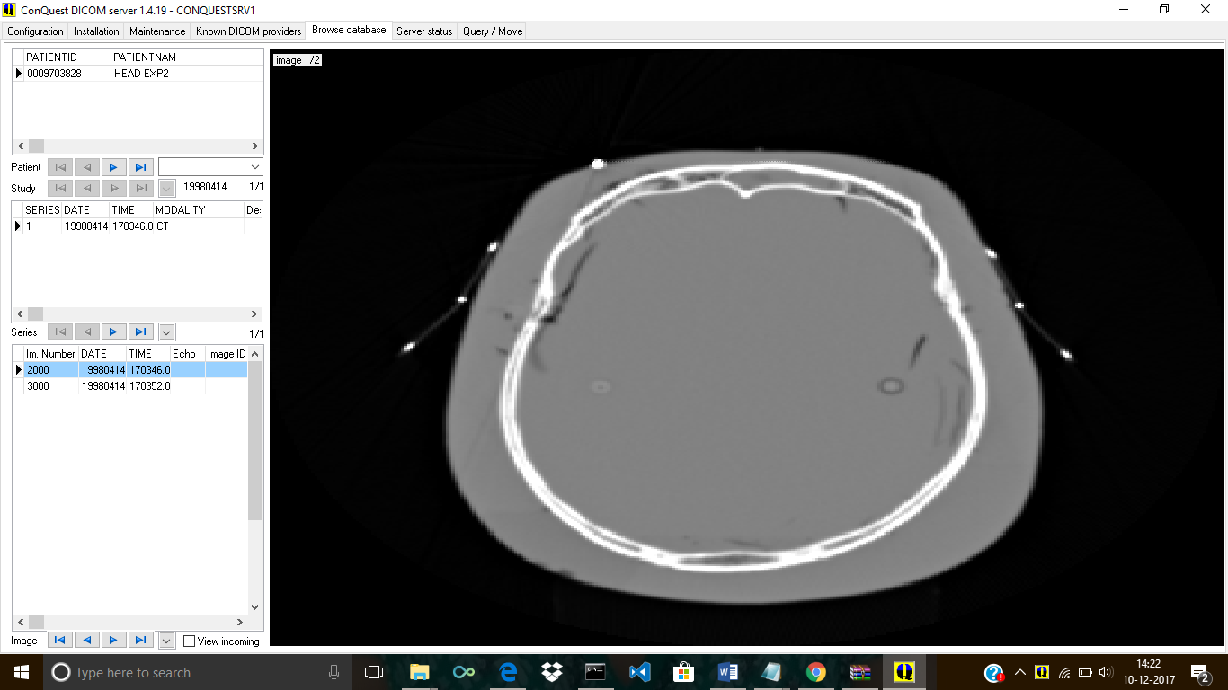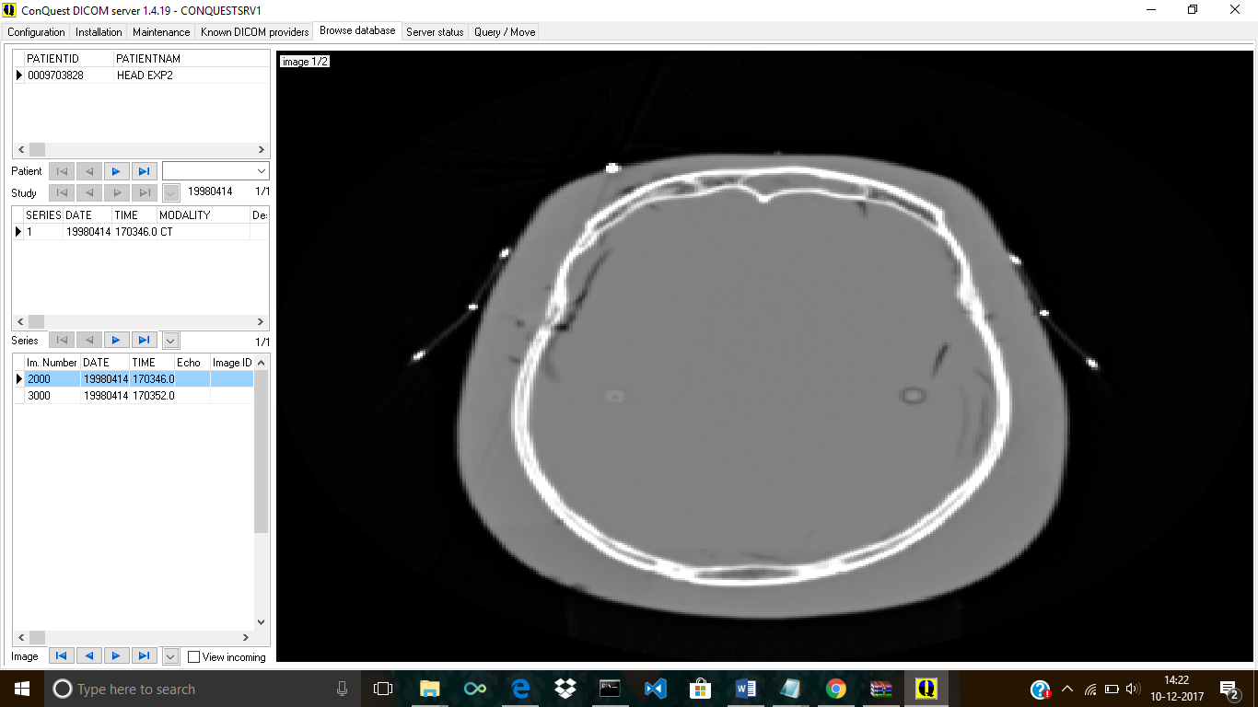

9) Check Server Status here-

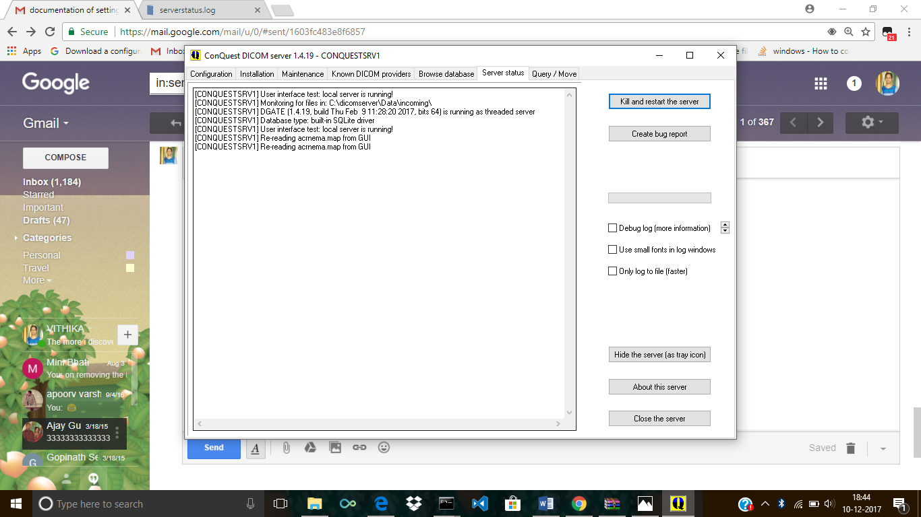

10)Query tab-

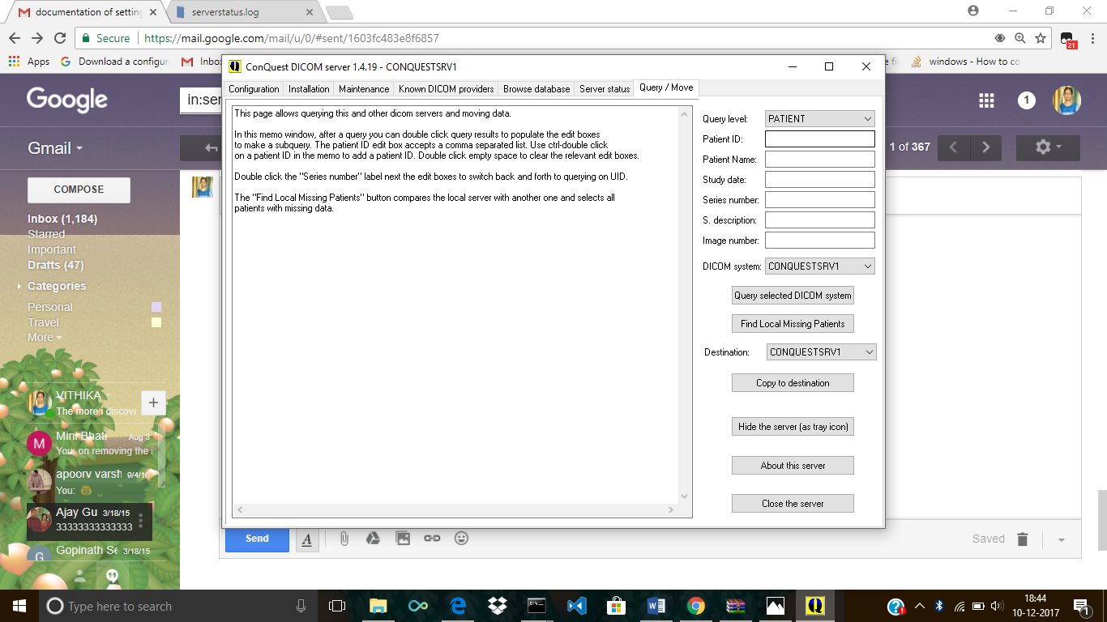

Query Level Options-

Query Level Patient—

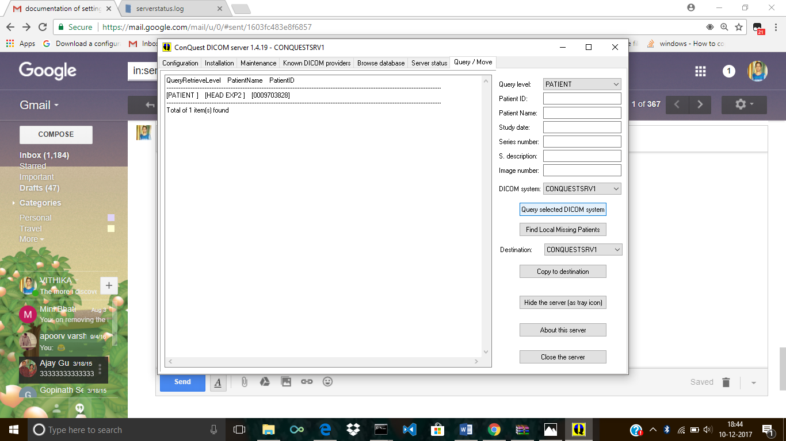

Query Level Study-

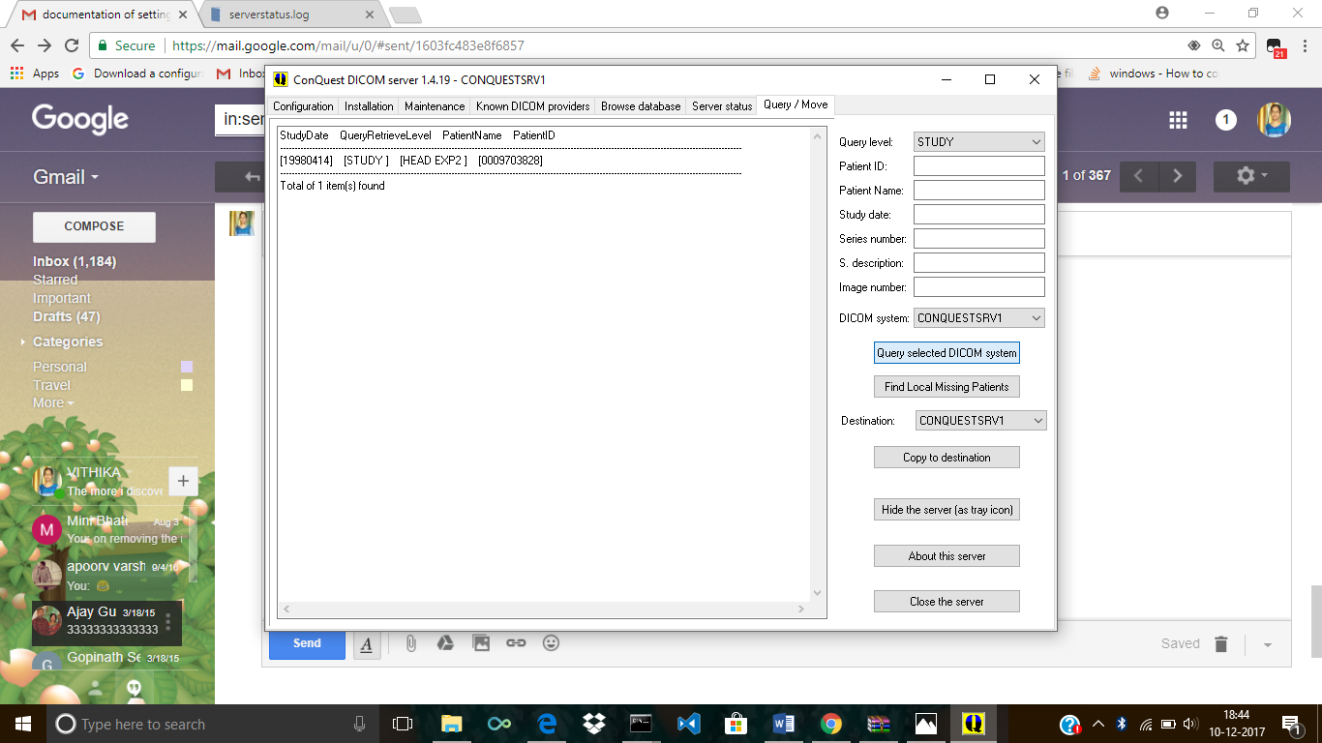

Query Level-Series-

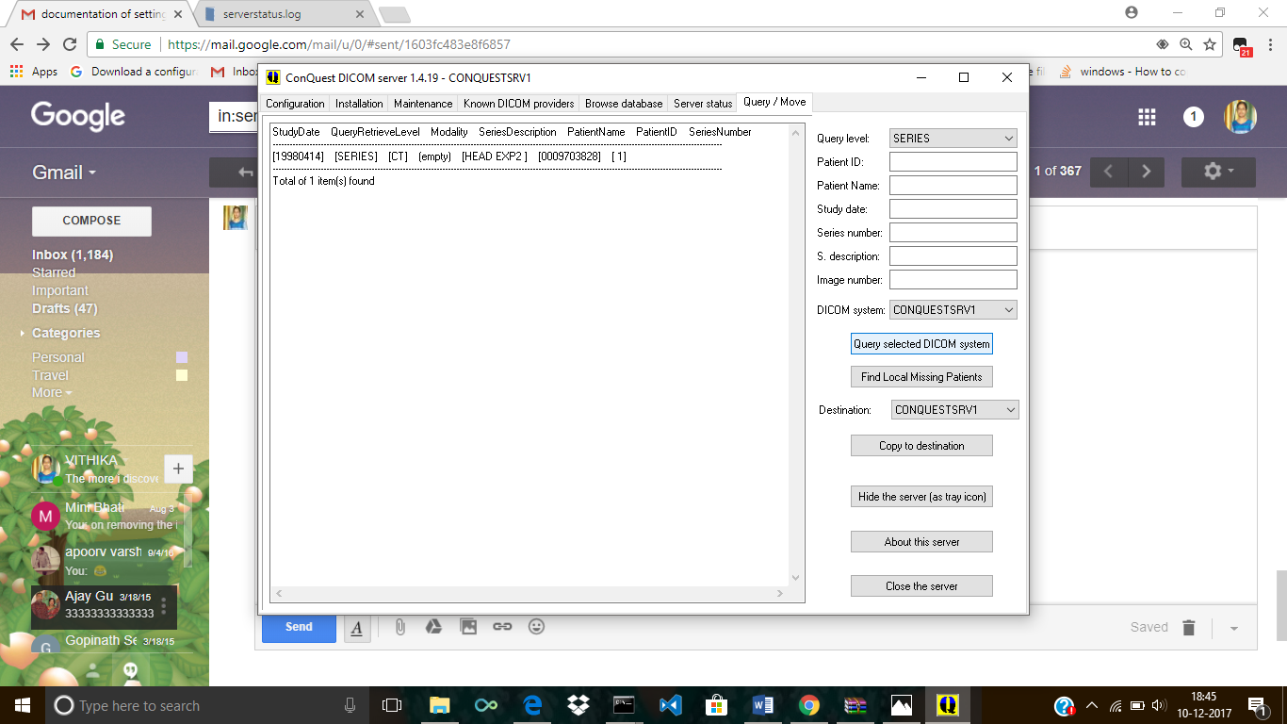

Query Level Image-

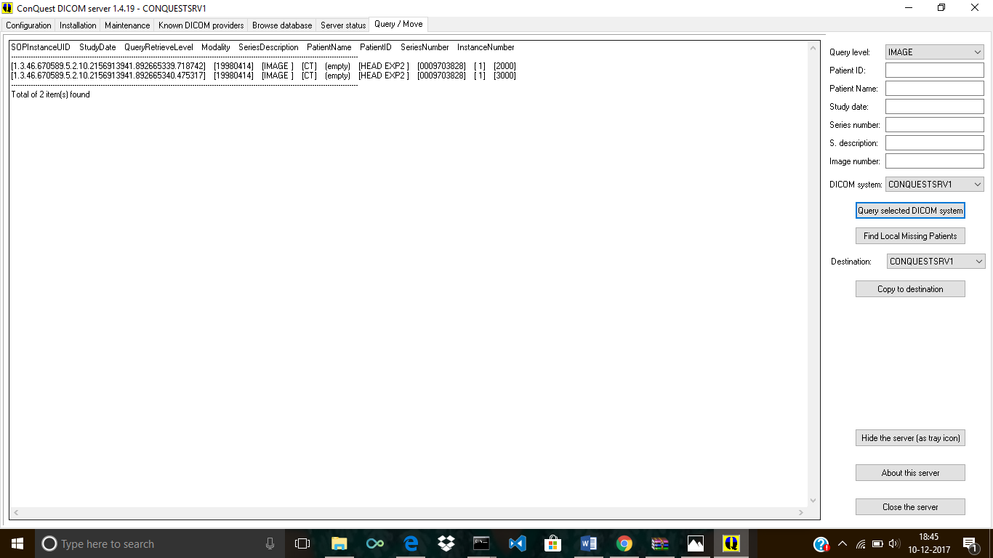

Query Level- Series Study Root-

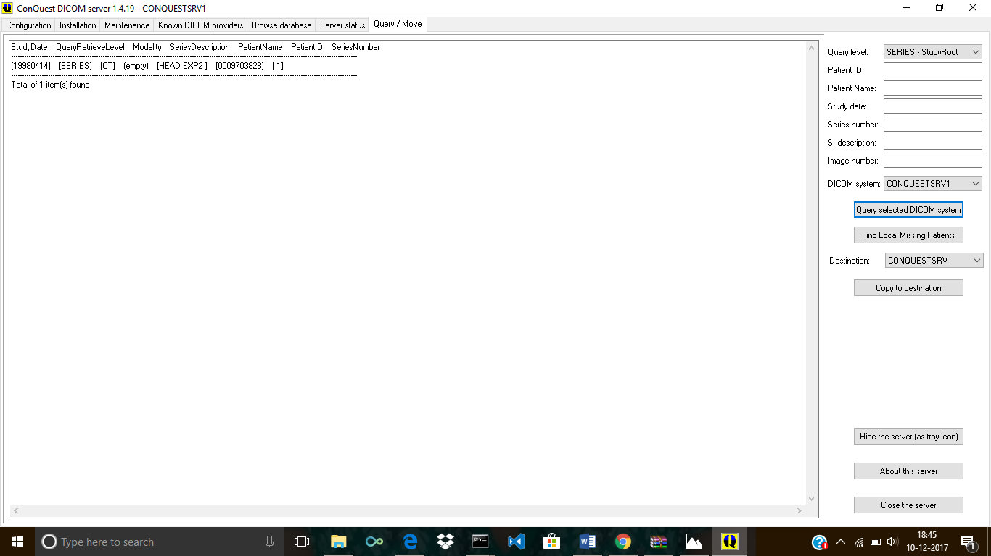

Query Level Study-StudyRoot

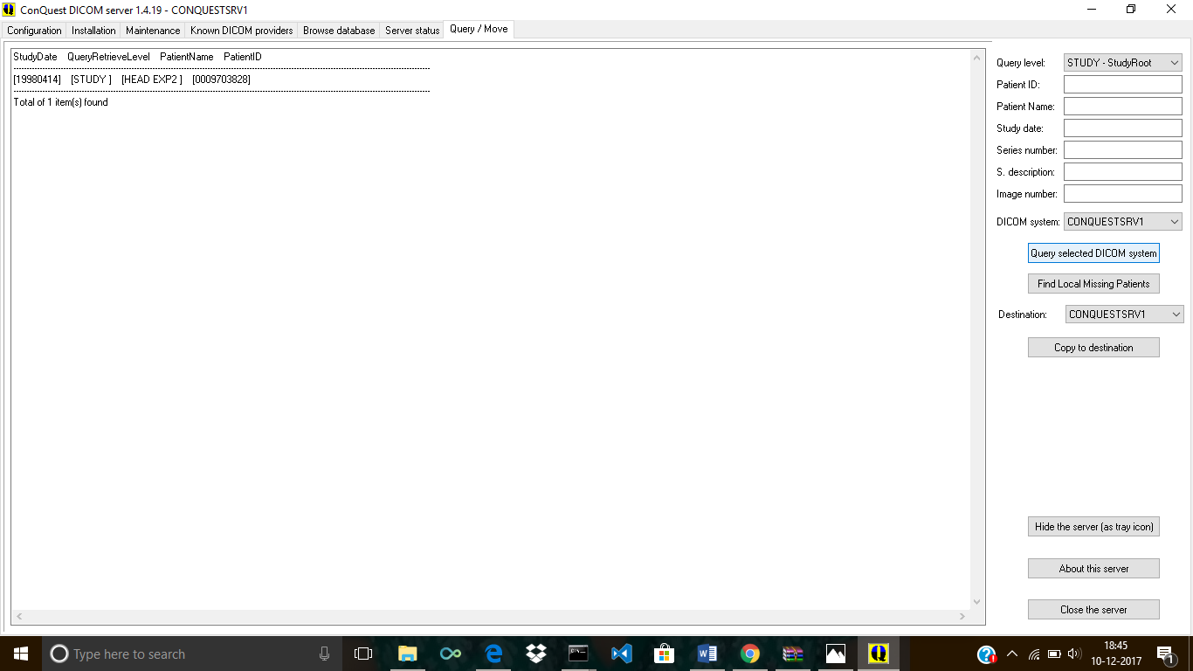

Image study Root-

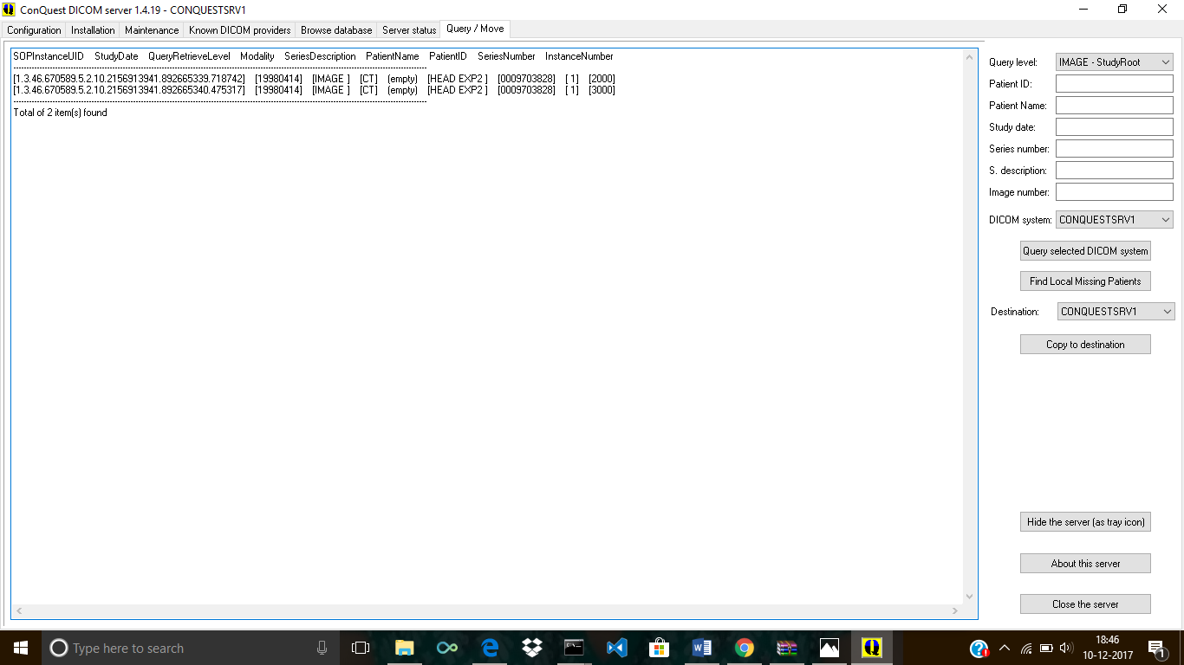

Copying To Destination-

